**NEA Evaluation Exemplars**

**Exemplar 1:**

# Evaluation

## Overall Effectiveness of the Solution

|  |  |  |
| --- | --- | --- |
| Objective | Met? | Comments |
| 1. At the beginning of the game, the information about the items and the enemies from the database should be loaded into the system | Yes | This objective was fully met. The information was loaded into the system every time the system is run. |
| 1. The game should have a login/register page which will be the first screen that loads once the game is started and it should:    1. Allow user to register an account by inputting the desired username and password into the text box input fields, which will then be stored in the database       1. The system should allocate an UserID to the user, which will uniquely identify them in the database       2. The system should check if the username entered already exists in the database and if that is the case display an error message       3. There should be an extra text box, prompting user to enter the password for the second time, and the system should check if the password match before inserting the data into the database          1. In case the password are not matching, an error message should be displayed    2. Allow user to log in using their credentials which are already in the database by inputting these into the input text box fields       1. The system will check the input against the database and grant access to the user if the match had been found       2. If the match was not found in the database, an error message will be displayed on the screen | Yes | The main objective, as well as the subobjectives were all fully met. The user can successfully register an account with their data or log in to the system with an already existing account. The user is also informed if any of the information they have entered is invalid and is prompted to try to login/register again. |
| 1. After the user has successfully logged in, the game should display the start menu    1. Start menu should consist of 4 buttons: play game, highscores, options and exit    2. User should be able to access options by pressing the options button       1. The options menu scene should be loaded, where the user should be able to alter sound settings using slider bars, which will be linked to a sound mixer in Unity – there should be 3 sliders for adjusting all volume, background music and the SFX sounds    3. User should be able to start the game by pressing the play game button       1. If the player is a returning user, they should be prompted with two options, which are ‘new game’ and ‘load game’          1. Selecting the ‘new game’ button should delete all of the scores associated with that player from the database, as well as reset its gameLevel to 1, skip the Level Selection Scene and open Level 1 directly instead          2. Selecting the load game button should allow the user to progress to the next scene without any changes made to their data in the system       2. The next scene loaded should be the level selection scene, where they will be able to choose which level they want to attempt by clicking one of the buttons          1. Only the levels which are equal or lower than the user’s current game level should be available to the player, while the buttons for accessing the rest of the levels should be disabled    4. User should be able to access score board by pressing the highscores button       1. The scores should be loaded into a list, and displayed on the screen       2. The high score scene should be loaded, where the user should be able to select for which level they want the scores displayed using a drop-down list system          1. User should not be able to select two levels simultaneously, as this will make the scores non interpretable, since it is not logical to compare scores from different levels       3. User should also be able to sort the scores, either by the score or the time taken to pass the level using checkboxes, in both ascending and descending order          1. The user should not be able to have 2 sort boxes checked at the same time          2. The sort should be performed using merge sort, and the score will need to be transferred from the list to an array to perform this action    5. User should be able to exit the program by pressing the exit button       1. In the exported version of the game, this should close the game the window is in       2. If the game is run in the Unity Editor, this should stop the Unity Editor’s play mode | Yes | The main objective, as well as the subobjectives were all fully met. The user can successfully progress to the main menu page from the login screen and can access other menus or start the game. The users can use the options menu to change the sound levels in the game, and can do this either for all sounds in the game, or for SFX sounds and music individually. From the play game menu, the user can either start a new game, deleting all of their previous progress, or load an already existing game, by using the load game function. The level selection menu allows user to only access the levels which they attempted before, as well as the next level. The user can view their scores, times and rankings using the highscore menu, where all of the scores for all of the players are available and can be either filtered or sorted using the checkboxes and drop-down lists on the screen. Exit function also works, allowing the user to close the program. |
| 1. The map for the game should be drawn in Unity using the Tilemap feature    1. The sprites for the tiles must be imported into a tile palette    2. The map must be made in the way that collisions with walls and solid objects can be detected, meaning that the user cannot pass through them | Yes | The main objective, as well as the subobjectives were all fully met. The user can move the player character on the map and is able to collide with objects, enemies and walls without any issues. |
| 1. The animations for character, enemies and item sprites must be made in Unity    1. Attack animations must be made for the player    2. Damage animations must be made for player and the enemies – the game object being attacked should blink red twice to indicate that it is losing health points    3. Idle and movement animations must be created for player and all of the enemies, in 4 directions – up, down, left and right | Yes | The main objective, as well as the subobjectives were all fully met. The animations are triggered when the user is moving the player and attacking, in all four directions. The user is also visually informed when damage is caused to their character, as the character is blinking red indicating the damage. The animations. The same also applies to the enemies. |
| 1. User should be able to teleport to different parts of the map when in the teleport trigger zone, marked with a teleport sprite | Yes | The main objective, as well as the subobjectives were all fully met. The user can teleport their character from one point of the map to another when interacting with the designated teleport signs. |
| 1. User should be able to control player movement using the keyboard keys; the character can move forward, backward, left and right    1. Pressing the W key should allow the user to move in the positive y direction    2. Pressing the S key should allow the user to move in the negative y direction    3. Pressing the A key should allow the user to move in the negative x direction    4. Pressing the D key should allow the user to move in the positive x direction | Yes | The main objective, as well as the subobjectives were all fully met. The user can move its character as described in the objective. |
| 1. Player’s remaining health points must be displayed to the user numerically in the top-right corner of the screen alongside a heart which will graphically represent the status of player’s health points    1. The player’s health must be managed using a health manager class       1. The player’s points should be stored in an integer variable       2. The manager should be able to modify player’s points (add to or deduct from them), depending on if the user was attacked by the enemy or gained health points by collecting an item    2. The graphical representation of the player’s health points remaining should accurately represent the numerical integer value compared to the maximum amount that can be stored       1. The numerical value should be displayed on the screen along with the graphical representation    3. The player’s health points should be reset at the beginning of each new level | Yes | The main objective, as well as the subobjectives were all fully met. The user can see their current health points displayed on the screen graphically and numerically. The health points are updated in real-time, increasing when the user collects items that boost their health points, such as cherries, and decreasing when they are attacked by one of the enemies. The user can also see their current status of health points displayed graphically, which allows them to quickly get a vague idea of their current health points. |
| 1. Player’s level points and current level should be displayed to the user using a level bar    1. The player’s points and level should be managed using a level manager class       1. Once the player has levelled up, the level progress bar should reset to zero, in order to accurately represent the player’s progress towards the next level       2. The manager should be able to modify player’s points (add points once a triggering action has been completed)       3. In order to level up, user should collect 15 coins while playing the game          1. The maximum level player can reach is Level 3, so after that level has been reached, the level manager should not allow user to level up any further       4. The player’s points should be stored in integer variable, and the level should be calculated based on the points when needed | Yes | The main objective, as well as the subobjectives were all fully met. The user can see their current level in the game, as well as how many points they have accumulated so far towards the next level. Once the user has reached the highest level in the game, the level progress bar is completely filled , indicating that no further progress can be made towards any higher levels. |
| 1. The user should be able to perform attacks    1. The user should be able to do this using the Q button    2. Player should be able to pick up different types of weapons on the map, which will be stored in the inventory and which the user will be able to switch between using 1, 2 and 3 keys       1. In case user has not collected a weapon yet, they should be unable to perform an attack       2. When the player performs the attack, the amount of damage points deducted from the enemy should depend on the weapon the player is using | Yes | The main objective, as well as the subobjectives were all fully met. The user is able to perform attack using the weapon selected from the inventory, and cause damage to the enemies. In case the user has not previously collected any weapons in the current game session at the time they want to perform the attack, the attack function will be disabled until a weapon is collected. |
| 1. The game should contain enemies/villains    1. The enemies should be able to move around the map       1. Type 1 of enemy should have fixed movements (e. g. this enemy will move along one axis only, either horizontal or vertical)          1. This type of enemy should change the direction of their movement when the hit a wall (if the enemy was moving to the right before the collision, it should start moving to the left)             1. The change in direction should only happen if the enemy collides with a wall and not with other objects – this should be regulated by using tags on the game objects       2. Type 2 of villain should start chasing the player once the player is at the certain distance from the villain          1. This should be implemented using Unity’s NavMesh feature, as this is the most efficient solution for pathfinding in a TileMap system          2. The enemy will know which game object to follow by using tags – it will only follow objects with ‘player’ tag located at a certain distance away from it    2. The enemies should have a health points system, visually represented using a health bar above the enemies’ heads       1. The enemies’ health must be managed using a health manager class          1. The enemies’ points should be stored in an integer variable          2. The manager should be able to modify enemy’s points (deduct from them)    3. The enemies should be able to attack the player       1. The attack should happen if a collision is detected between an object tagged as ‘player’ and an object tagged as ‘enemy’       2. Enemy attacks should be able to take health points off the player       3. The player’s animation should then be switched to the damage animation using a coroutine and the attack should be temporarily disabled since otherwise the health points will be taken off the player constantly as long as the player’s and the enemy’s colliders are touching    4. The player should score points when defeating enemies       1. Defeating Type 1 enemy should add 10 points to the player’s score       2. Defeating Type 2 enemy should add 15 points to the player’s score | Yes | The main objective, as well as the subobjectives were all fully met. All of the villains behave as expected, both the Type 1 villain, which always moved in the same path, and the Type 2 villain, which follows the player once they are in a certain radius around it. The user can see the current health status of the enemies thanks to the health status bar above their heads which is updated in real-time. The user’s health bar, as well as the enemies’ health bars are updated when damage is caused. The user can kill the enemies by bringing their health points to zero, at which point they disappear from the map. |
| 1. The game should have a pause menu    1. The button to enter the pause menu should be displayed in the top right corner    2. The game clock should stop when the pause menu is being displayed    3. The pause menu scene should include 3 buttons: resume, options and exit    4. The user should be able to return to the current game session when the resume button is pressed, and the game clock should resume from the point where it was stopped    5. The user should be able to leave the game and return to the main menu when the exit button is pressed    6. The user should be able to access the sound menu once the options button is pressed       1. The sound menu should replace the pause menu when selected       2. The sound menu should have a return button, so that the user can do back       3. The sound menu should have 3 sliders – all sounds, music, SFX sounds; this is similar to the options menu that can be accessed from the main menu | Yes | The main objective, as well as the subobjectives were all fully met. The user can choose to pause the game session whilst playing, which in result pauses the game clock and opens the pause menu. The user can then choose from 3 different options in the menu – they can return to the game and restart their game clock, they can go to the options menu and change the sound levels, or exit the current game session. |
| 1. The game should have items    1. The items should be retrievable on the map       1. When the player enters the radius of the item, they should be able to pick it up    2. There should be 3 types of items present on the map – coins, weapons and cherries       1. Collecting coins will contribute to the player’s level as well as the score in the current level          1. Collecting a coin adds 10 points towards the player’s level, as well as 10 points to the current level score       2. Weapons that are collected should be stored in the inventory, available for the player to use to attack the enemies on that level          1. There should be 3 types of weapons in the game, where each weapon will have a different value of damage points             1. Steal sword should have 20 damage points             2. Bronze sword should have 25 damage points             3. Gold sword should have 30 damage points          2. The weapons with the least amount of damage points should appear in the earlier levels and the weapons with more damage points should appear on the maps of more difficult levels       3. Collecting cherries should heal the player, adding additional health points to player’s current health points          1. A cherry should restore 10 health points of the player | Yes | The main objective, as well as the subobjectives were all fully met. The player is able to collect the items on the map, which trigger certain functions – the coins contribute to the scores, cherries contribute to the player’s health points, and the weapons are added to player’s inventory for later use. |
| 1. The game should have an inventory, located in the bottom-left corner of the screen    1. The inventory should be empty at the start of each level and only the weapons collected should be placed here | Yes | The main objective, as well as the subobjectives were all fully met. The user is able to store the weapons they collect during a game session in the inventory, and select the one they want to use at the moment using the designated keys. |
| 1. Each level of the game should have a scoring system    1. Player accumulates points by collecting coins and defeating enemies       1. The points should be managed using a Score Manager class, which should add up the points from collecting the coins and defeating the enemies throughout the duration of the current level session and display them on the screen in real-time    2. The score should be reset at the start of each level    3. The final score and time of each level will determine the user’s position in the leaderboards for each level       1. Performance of the player is based on the amount of time it took the player to complete the level or number of points accumulated on that level | Yes | The main objective, as well as the subobjectives were all fully met. The user can see their score on the screen which is updated in real-time. The total score at the end of the level will be entered to the highscore table alongside with the user’s username, which will allowed them to be ranked against other players and see how their score compares to other scores. |
| 1. The final level of the game should include 2 scenes, the first one being a maze map, similar to other levels, and the second being a turn-based combat against the boss    1. For this level, the health points of the player should be transferred from one scene to another, unlike for other levels    2. The options for the player in the boss fight should be ‘attack’ and ‘heal’ which the player will be able to select using buttons    3. Defeating the boss enemy should add 20 points to the player’s score | Yes | The main objective, as well as the subobjectives were all fully met. The user can challenge the boss enemy in the second part of the final level, and attack it or defend themselves using the on-screen buttons. By defeating the boss enemy, the user has successfully completed the game. |
| 1. The game should have a saving feature    1. Player’s progress should be saved by saving the index of the last level that has been completed in the database    2. The player should then be able to access all of the level that they have previously completed, as well as the next level of the game | Yes | The main objective, as well as the subobjectives were all fully met. The level which was completed by the user the last is automatically saved upon the completion of the level, which allows them to continue from where they have left off the next time they boot up the game and log into their account. Although this feature was implemented as intended, a better way to do this might have been using serialization, which would allow the player to save their progress inside of the level, rather than the last level completed. However, as this is a game does not contain many levels, and the levels themselves are not very complex, I felt like this was not necessary for the game to function properly. Having said this, it is something that could be added as an extension to the current system in the future. |
| 1. The game should have music and sound effects    1. The sounds effects should be played when certain events happen in the game, such as walking, attack, level complete, game complete etc.    2. The menu and the levels should have their own music, unique to that setting       1. The music should loop in the menu and the levels after the track is finished | Yes | The main objective, as well as the subobjectives were all fully met. Different background sounds are looped for different levels and menus. The user can trigger certain SFX sounds by doing different actions, such as clicking the buttons, moving the character on the map, or attacking enemies. |
| 1. All of the character in the game should inherit from a ‘Character’ base class, where virtual functions should be created which will be overridden in the children classes | Yes | This objective is fully met. All of the characters in the game inherit their basic properties from one, main class. |
| 1. Once a player has reached the endOfLevel checkpoint on the map, a Level Complete screen should be loaded over the level, displaying the player’s score and time taken to complete the level    1. The player’s statistics should be recorded in the database, along with player’s UserID    2. The gameLevel entity in the User table of the database should be increased by one, which should also enable the button to select the next level on the level selection screen    3. Underneath the statistics overview, there should be 3 buttons available for the player to interact with – ‘next level’, ‘retry level’ and ‘exit’       1. ‘Next level’ button should allow user to play to the next level by loading the scene associated with that level       2. ‘Retry level’ button should allow the user to attempt the same level again, by reloading the scene       3. ‘Exit’ button should return the user to the main menu    4. If the player has failed to reach the end of the level, an adapted, ‘game over’ version of this screen should be displayed       1. This screen should only have the buttons to retry the level or exit, as the user has not fulfilled the requirements to continue to the next level    5. If the player has completed the final boss fight in level 3, an adapted version of this screen should be displayed, congratulating the user on finishing the game, with only one option to exit and return to the main menu | Yes | The main objective, as well as the subobjectives were all fully met. The user is informed of their completion of the level by the level complete screen, which displays their final score and time taken to finish the level. This information it then transferred to the database and is available for the user to view from the highscore menu. From the level complete screen, the user can choose to progress to the next level, retry the same level, or exit the game. Different adaptations of this screen are displayed to the user, based on the outcome of the game session. |
| 1. The game should have a gameManager script, which is called in the main menu and controls the game    1. This script should be responsible for regulating sound volumes and managing the flow of data from and to the database | Yes | This objective is fully met. The data is managed by the script during the runtime of the program as expected, allowing for the game to function properly. |

The evidence for meeting the objectives is clearly visible from the Testing video linked in the Testing section under Testing Evidence subsection.

## User Feedback

In this section I will showcase the results of the acceptance testing which was completed by 10 test users as well as their written feedback they have sent back alongside this form.

Test User 1:

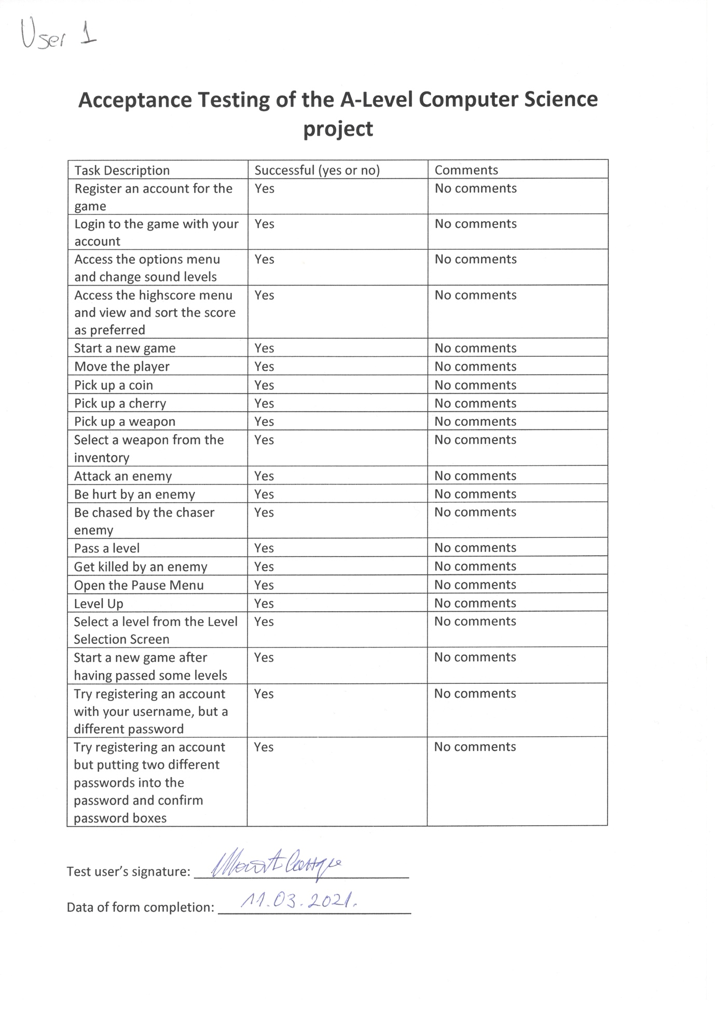

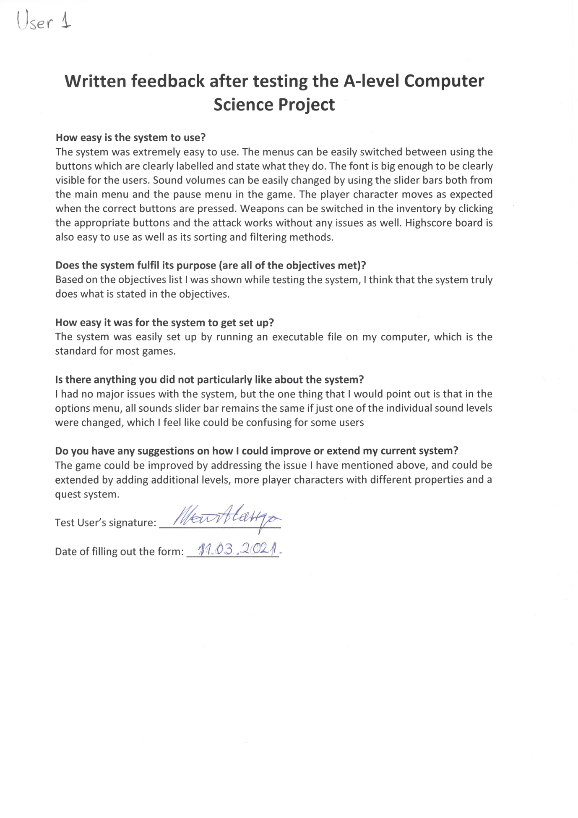

Test User 2: 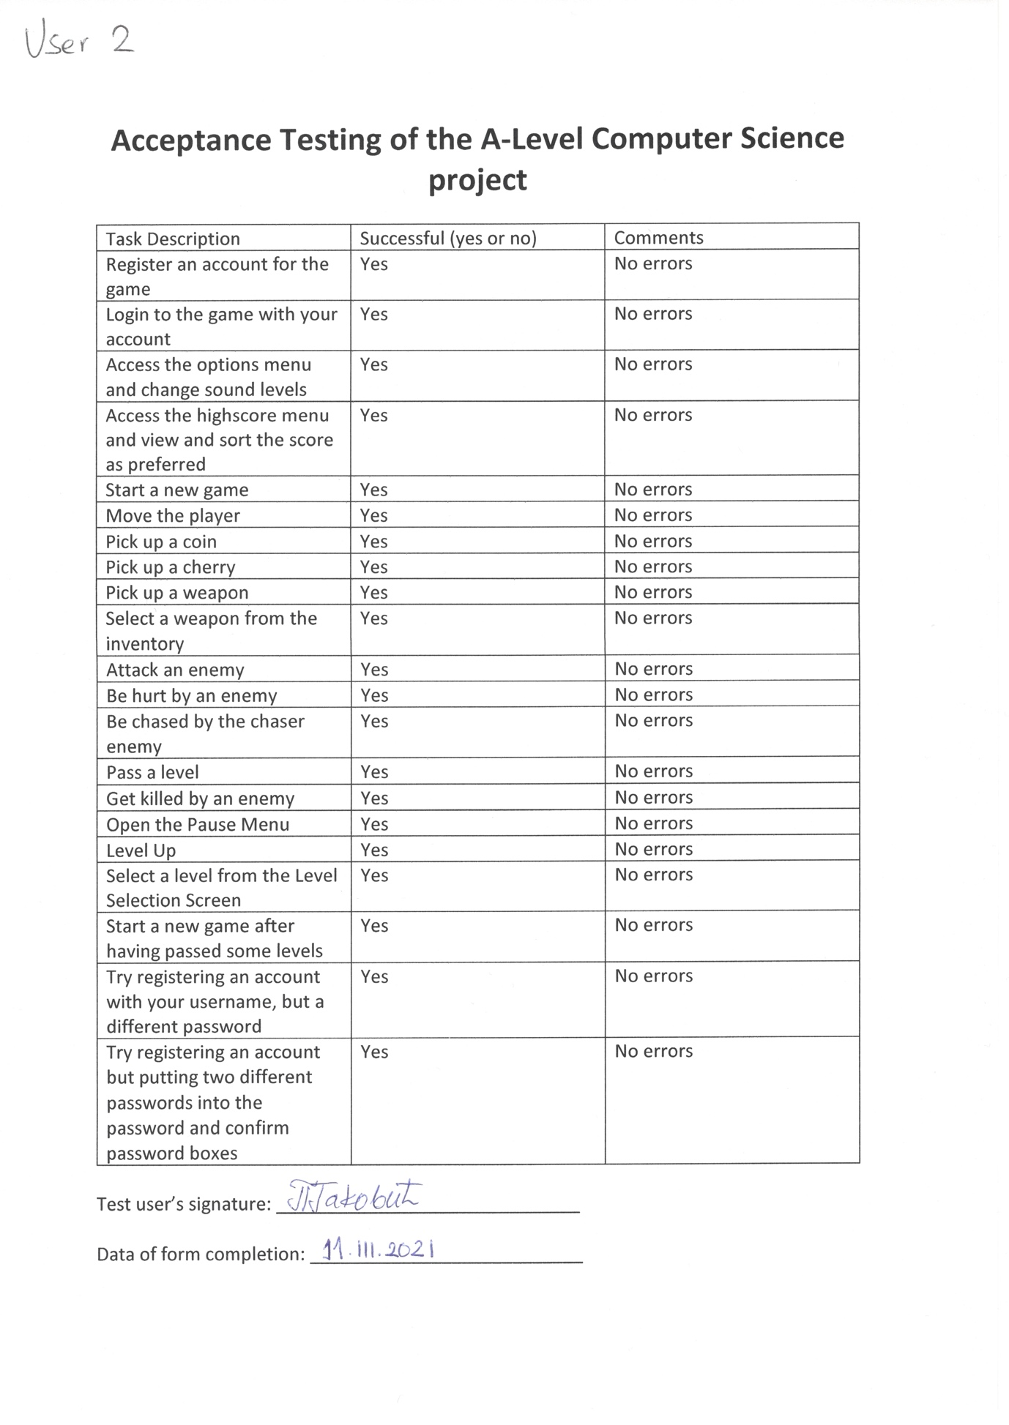

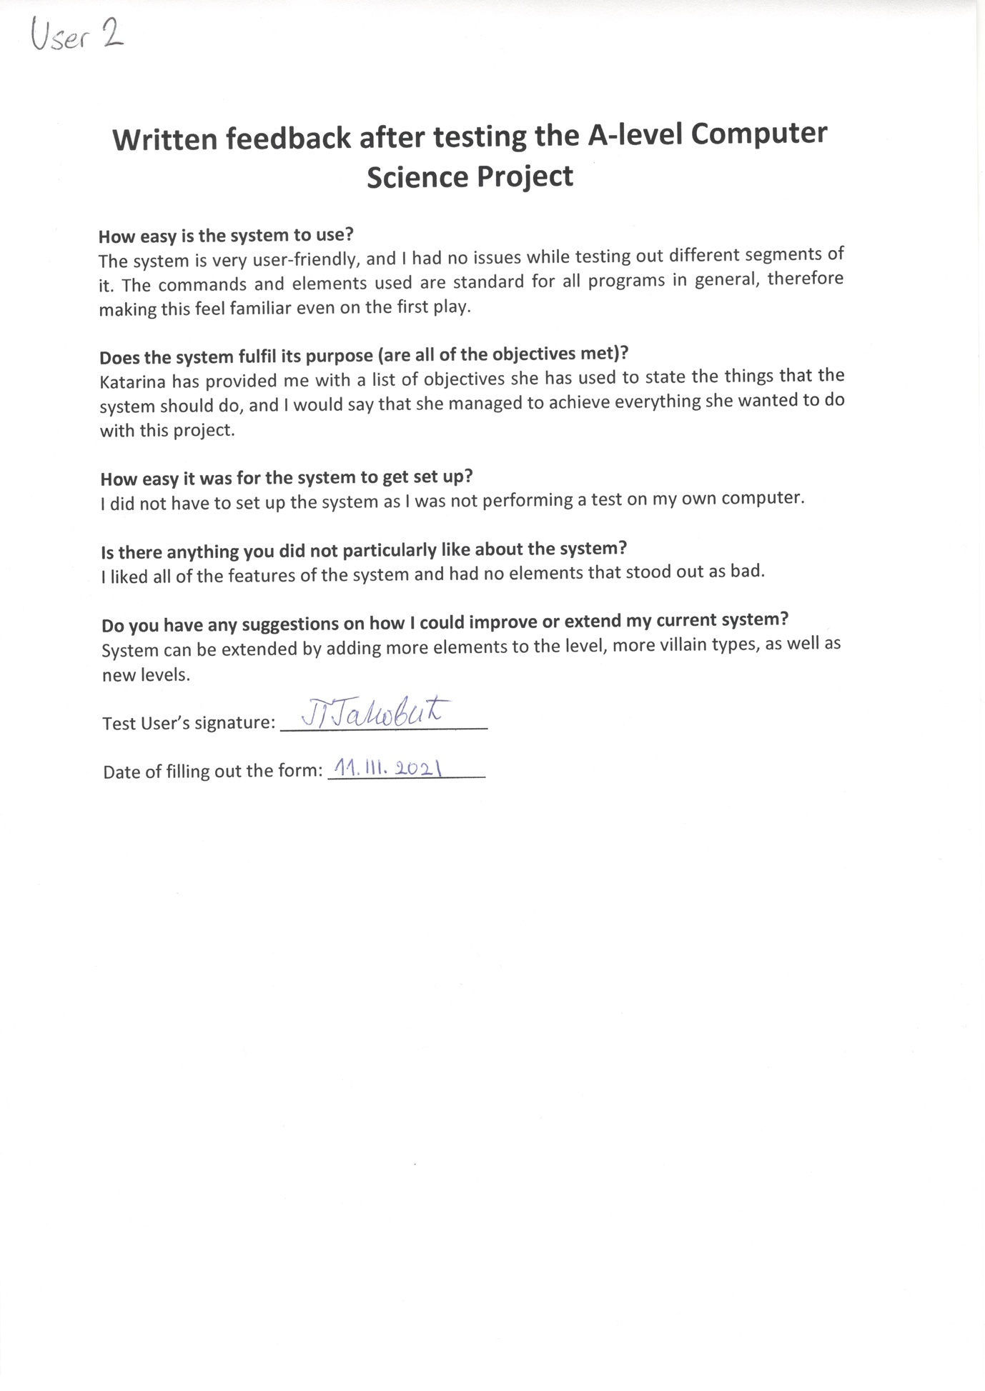

Test User 3: 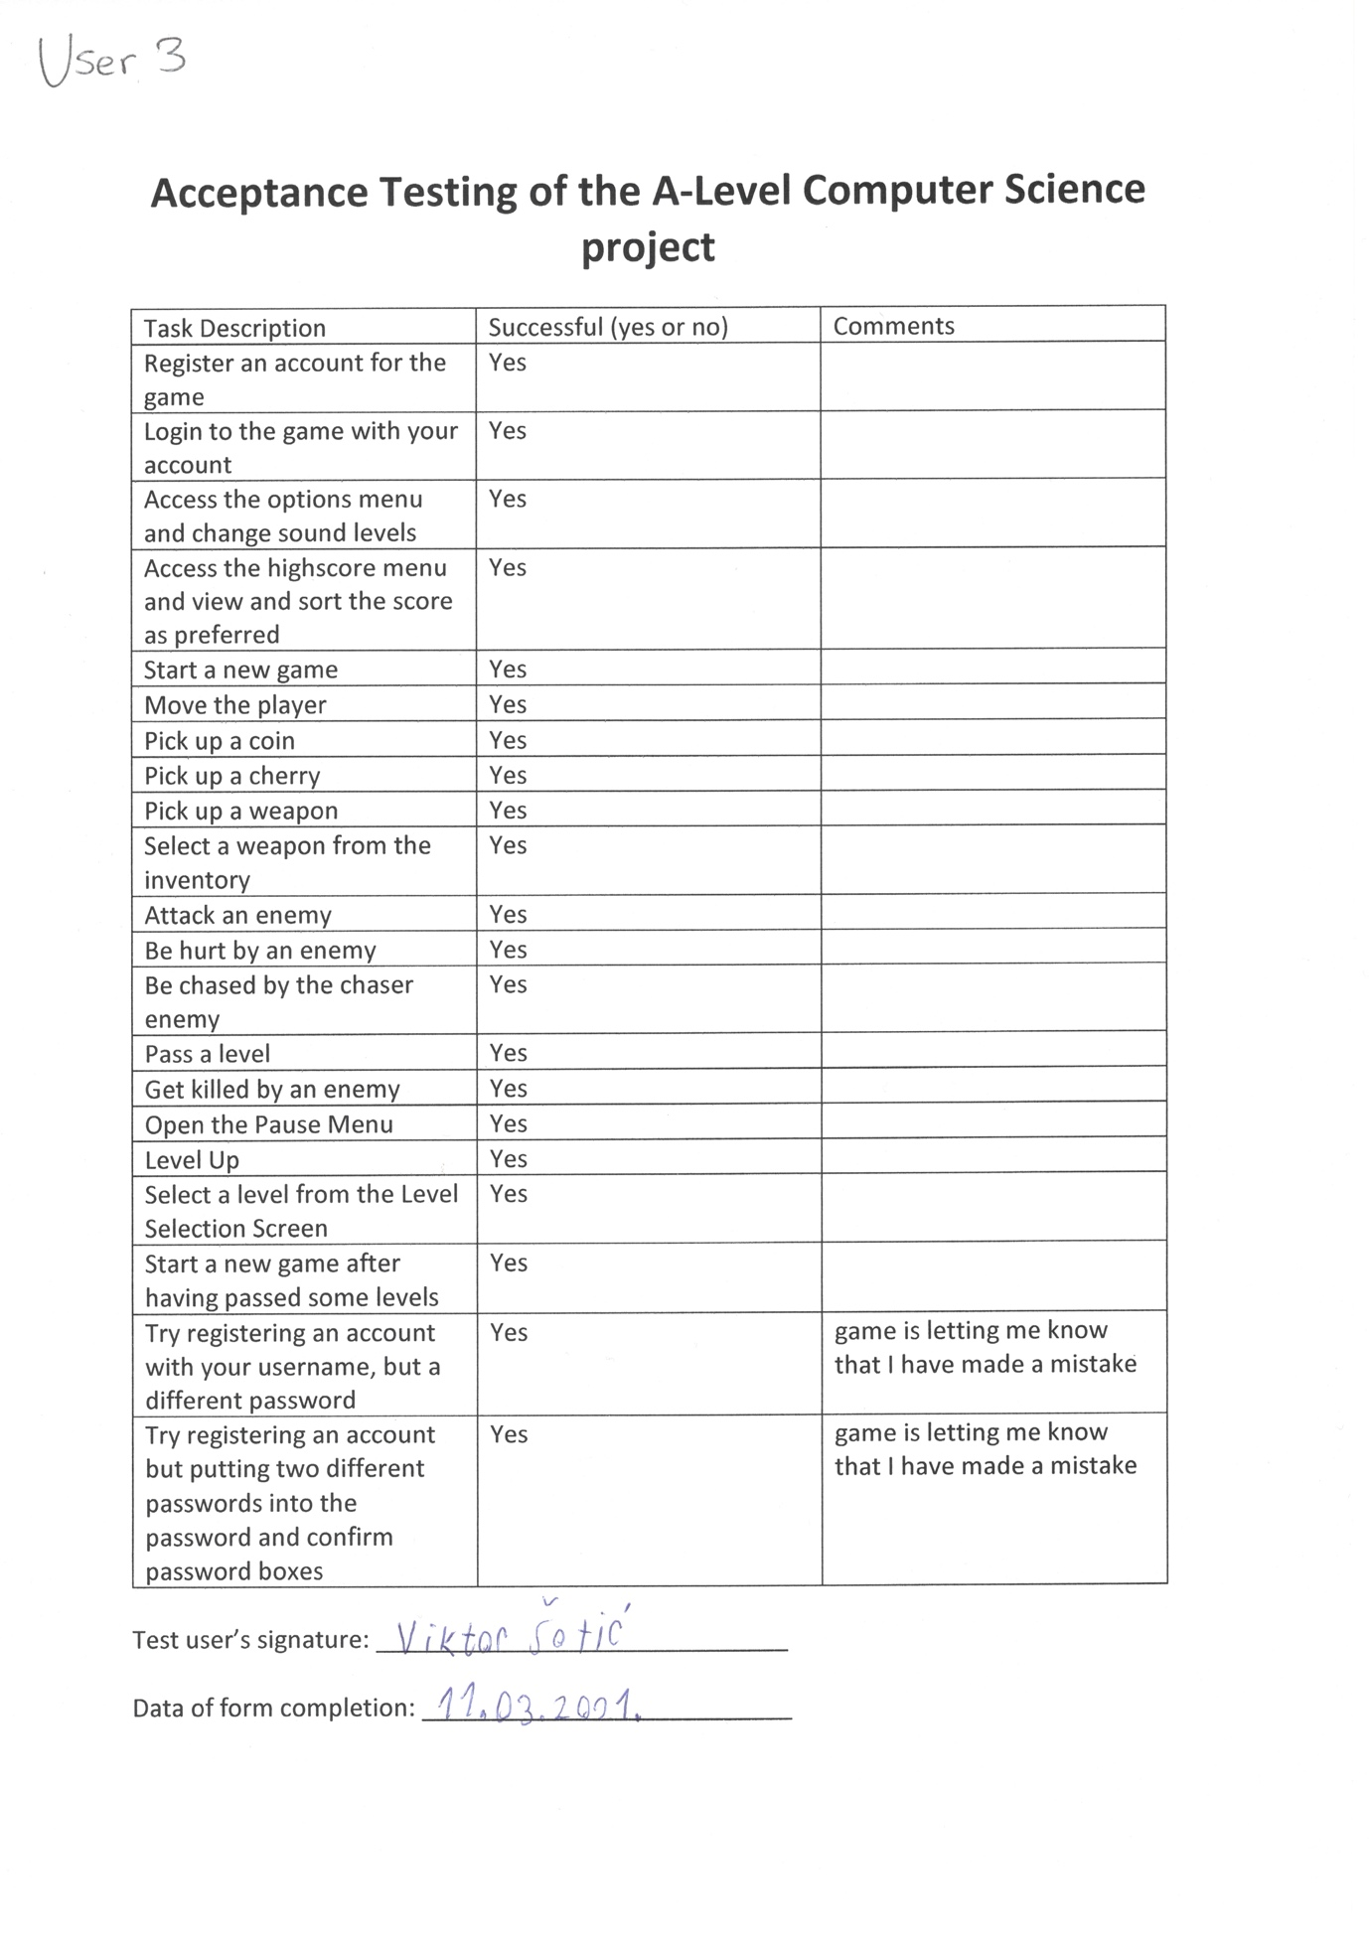

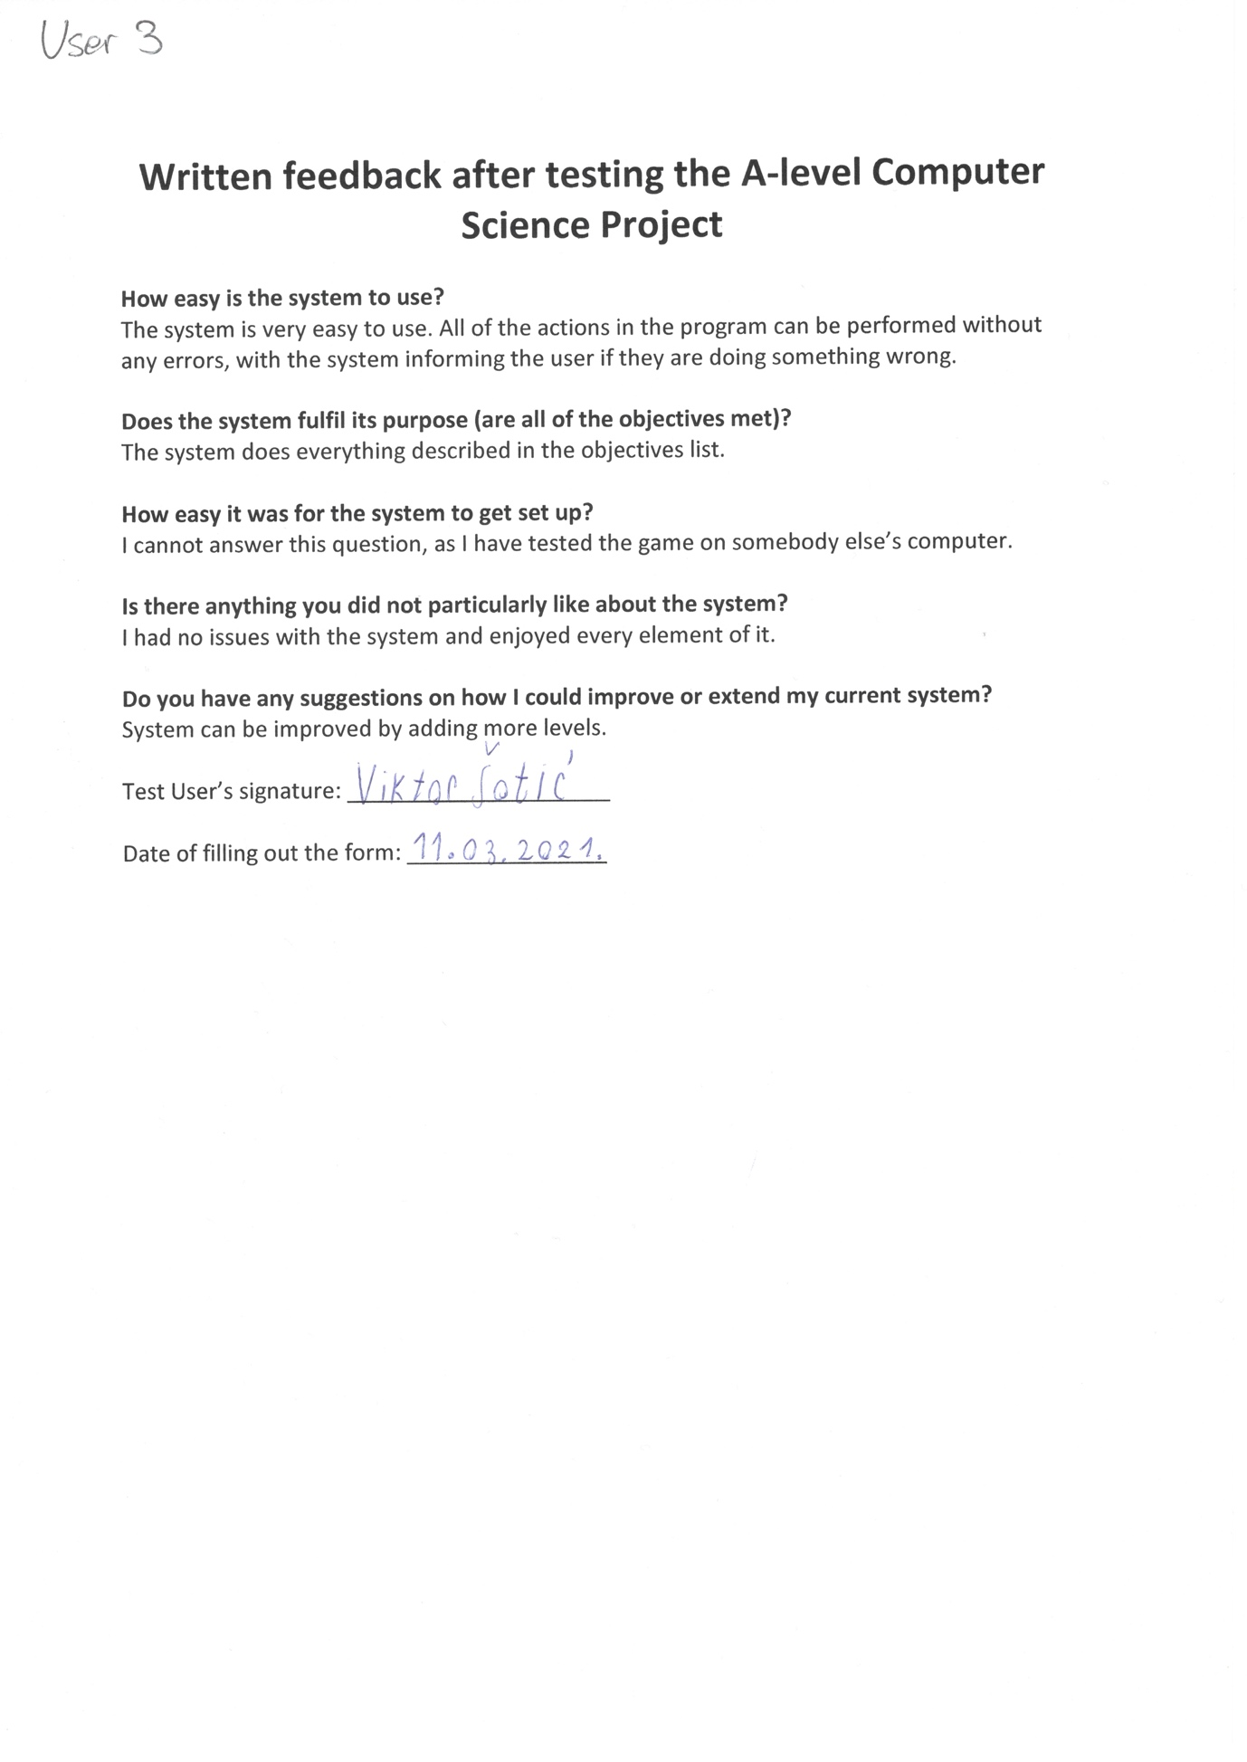

Test User 4:

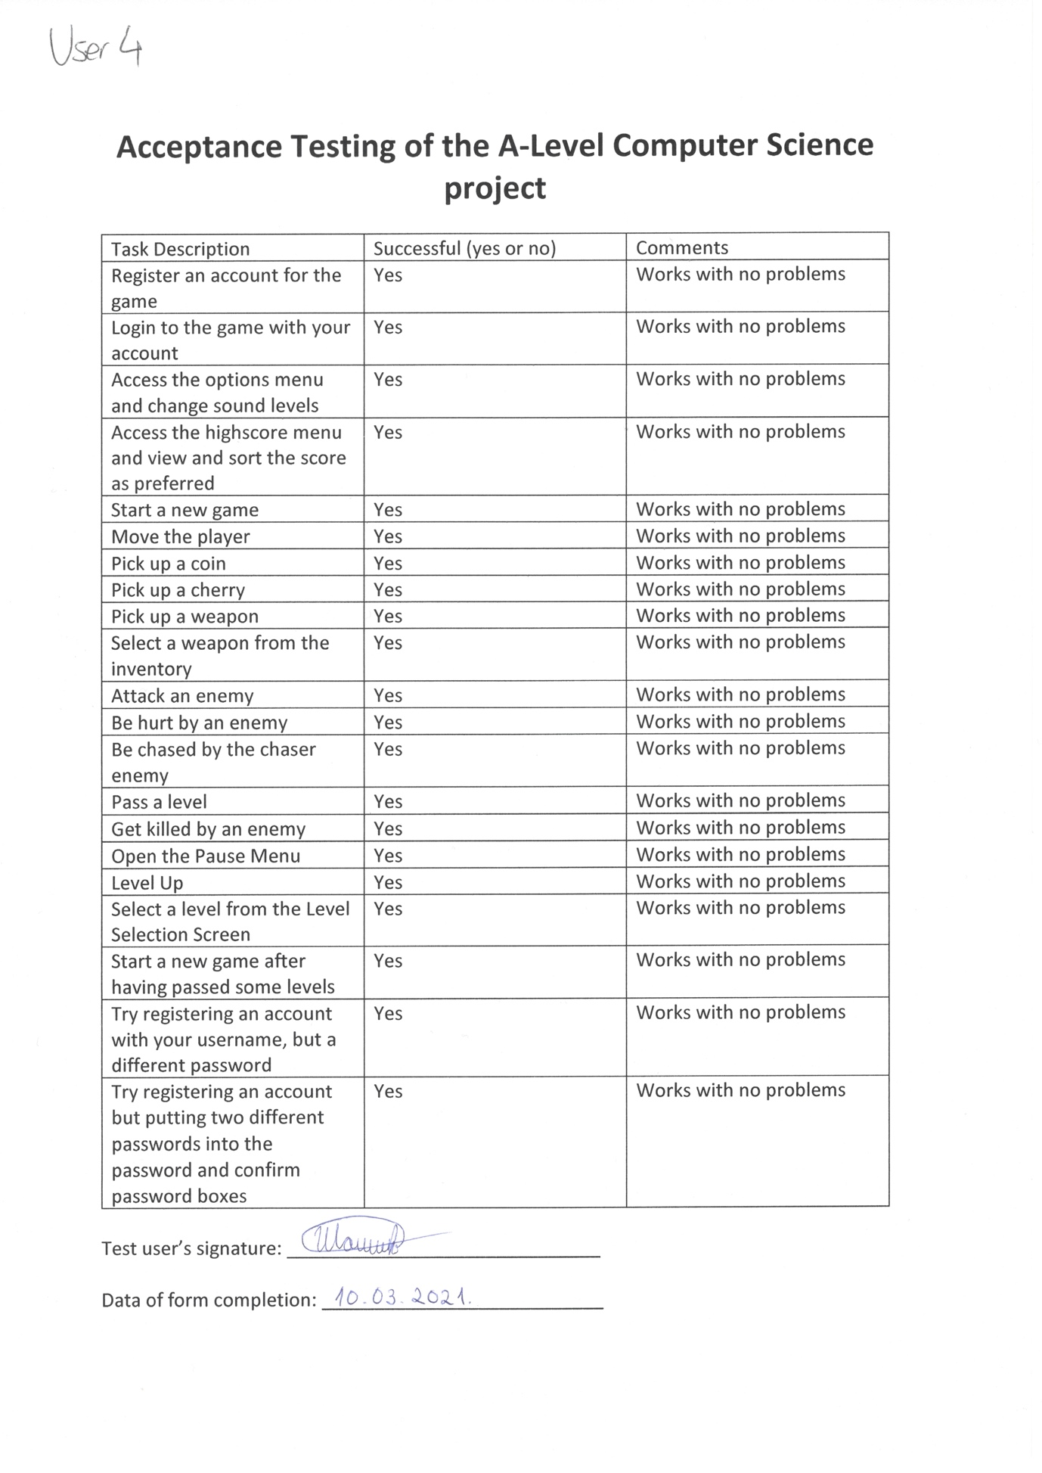

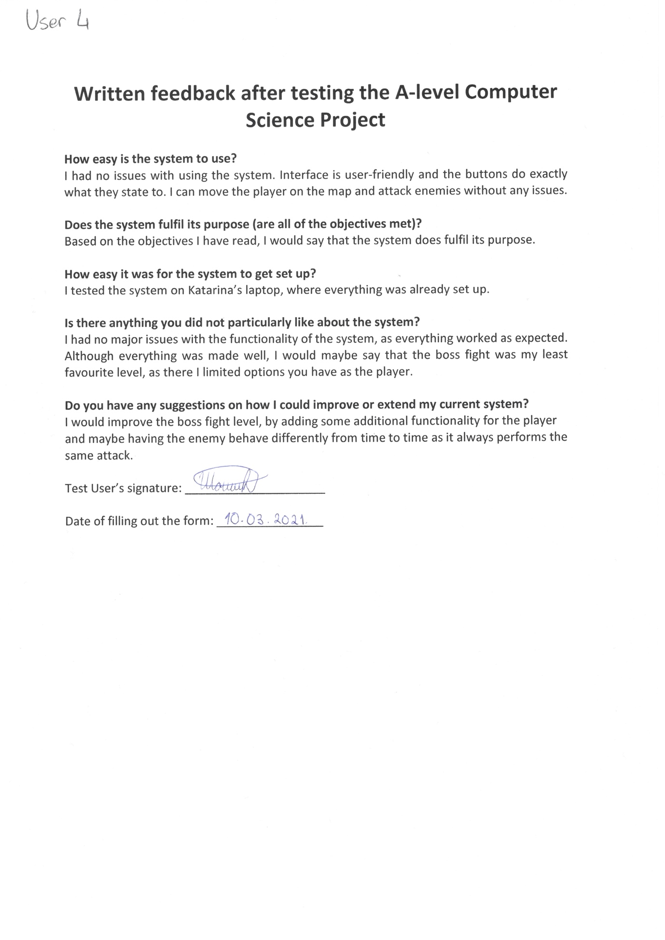

Test User 5:

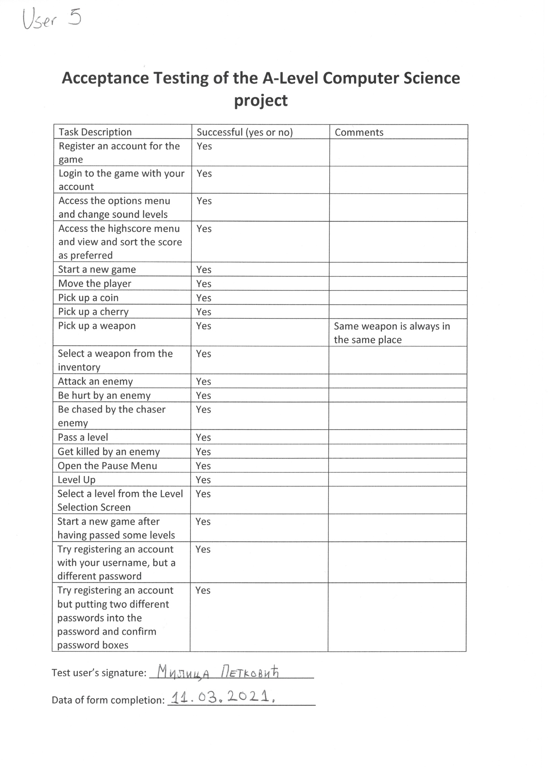

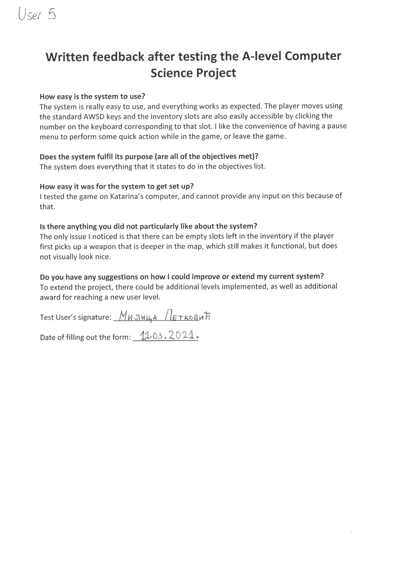

Test User 6:

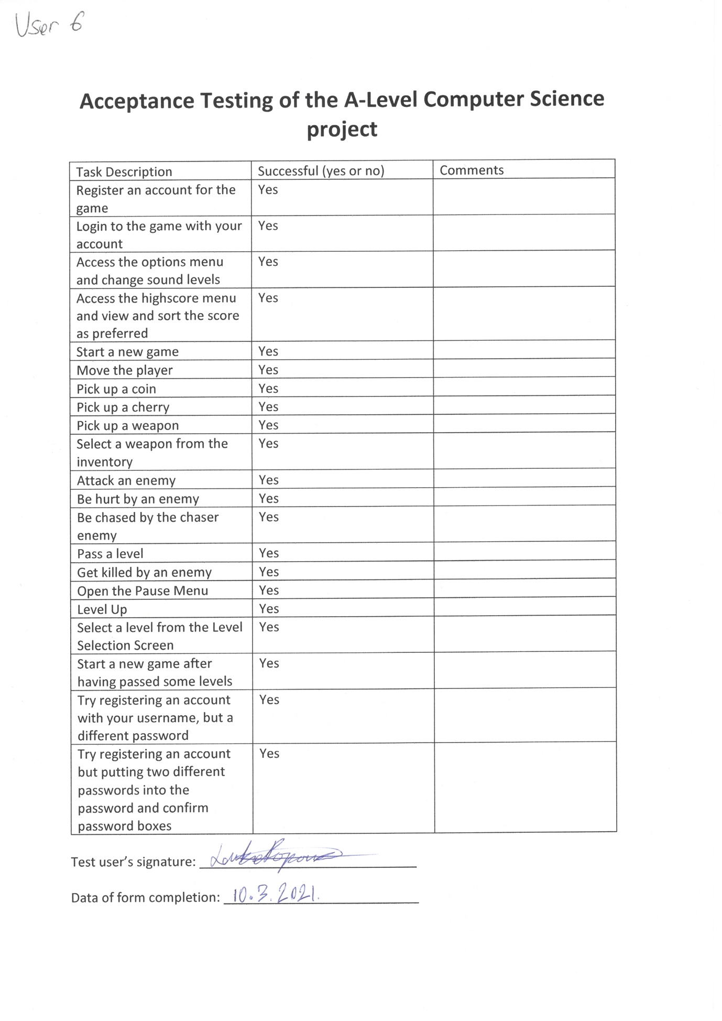

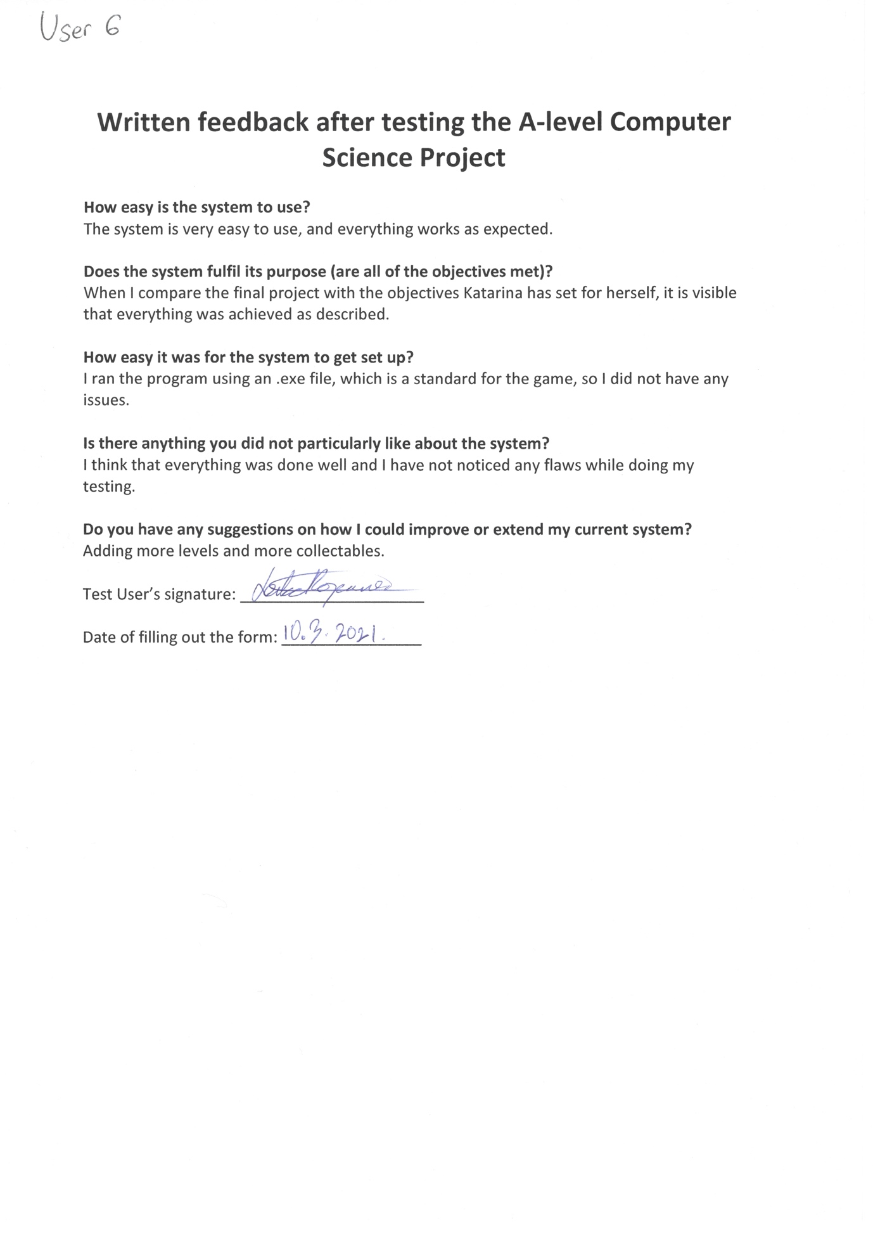

Test User 7:

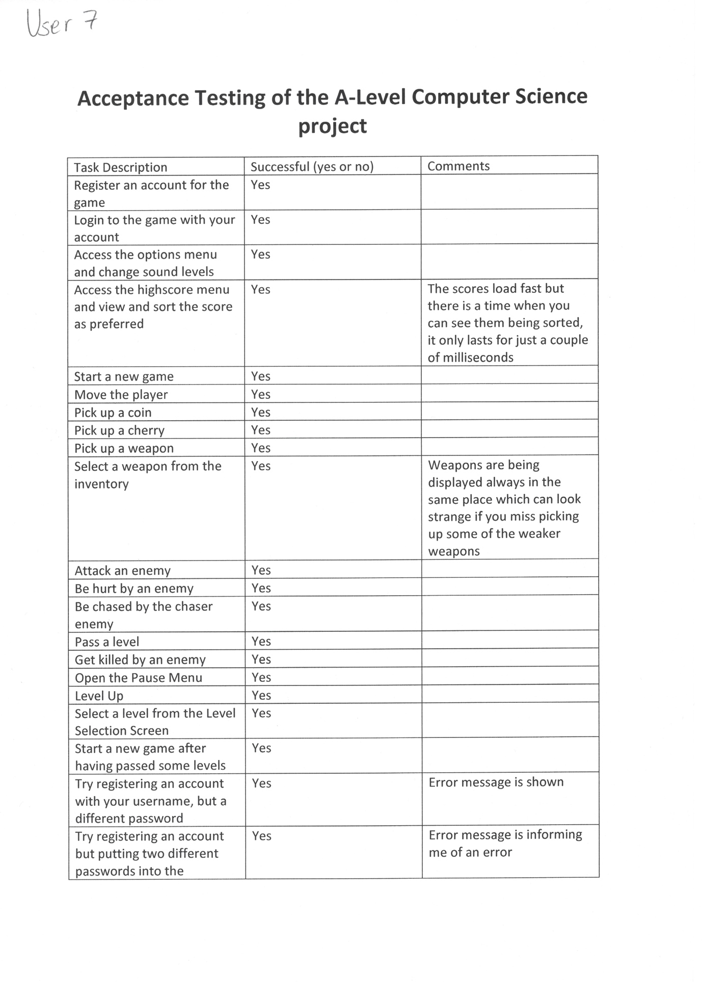

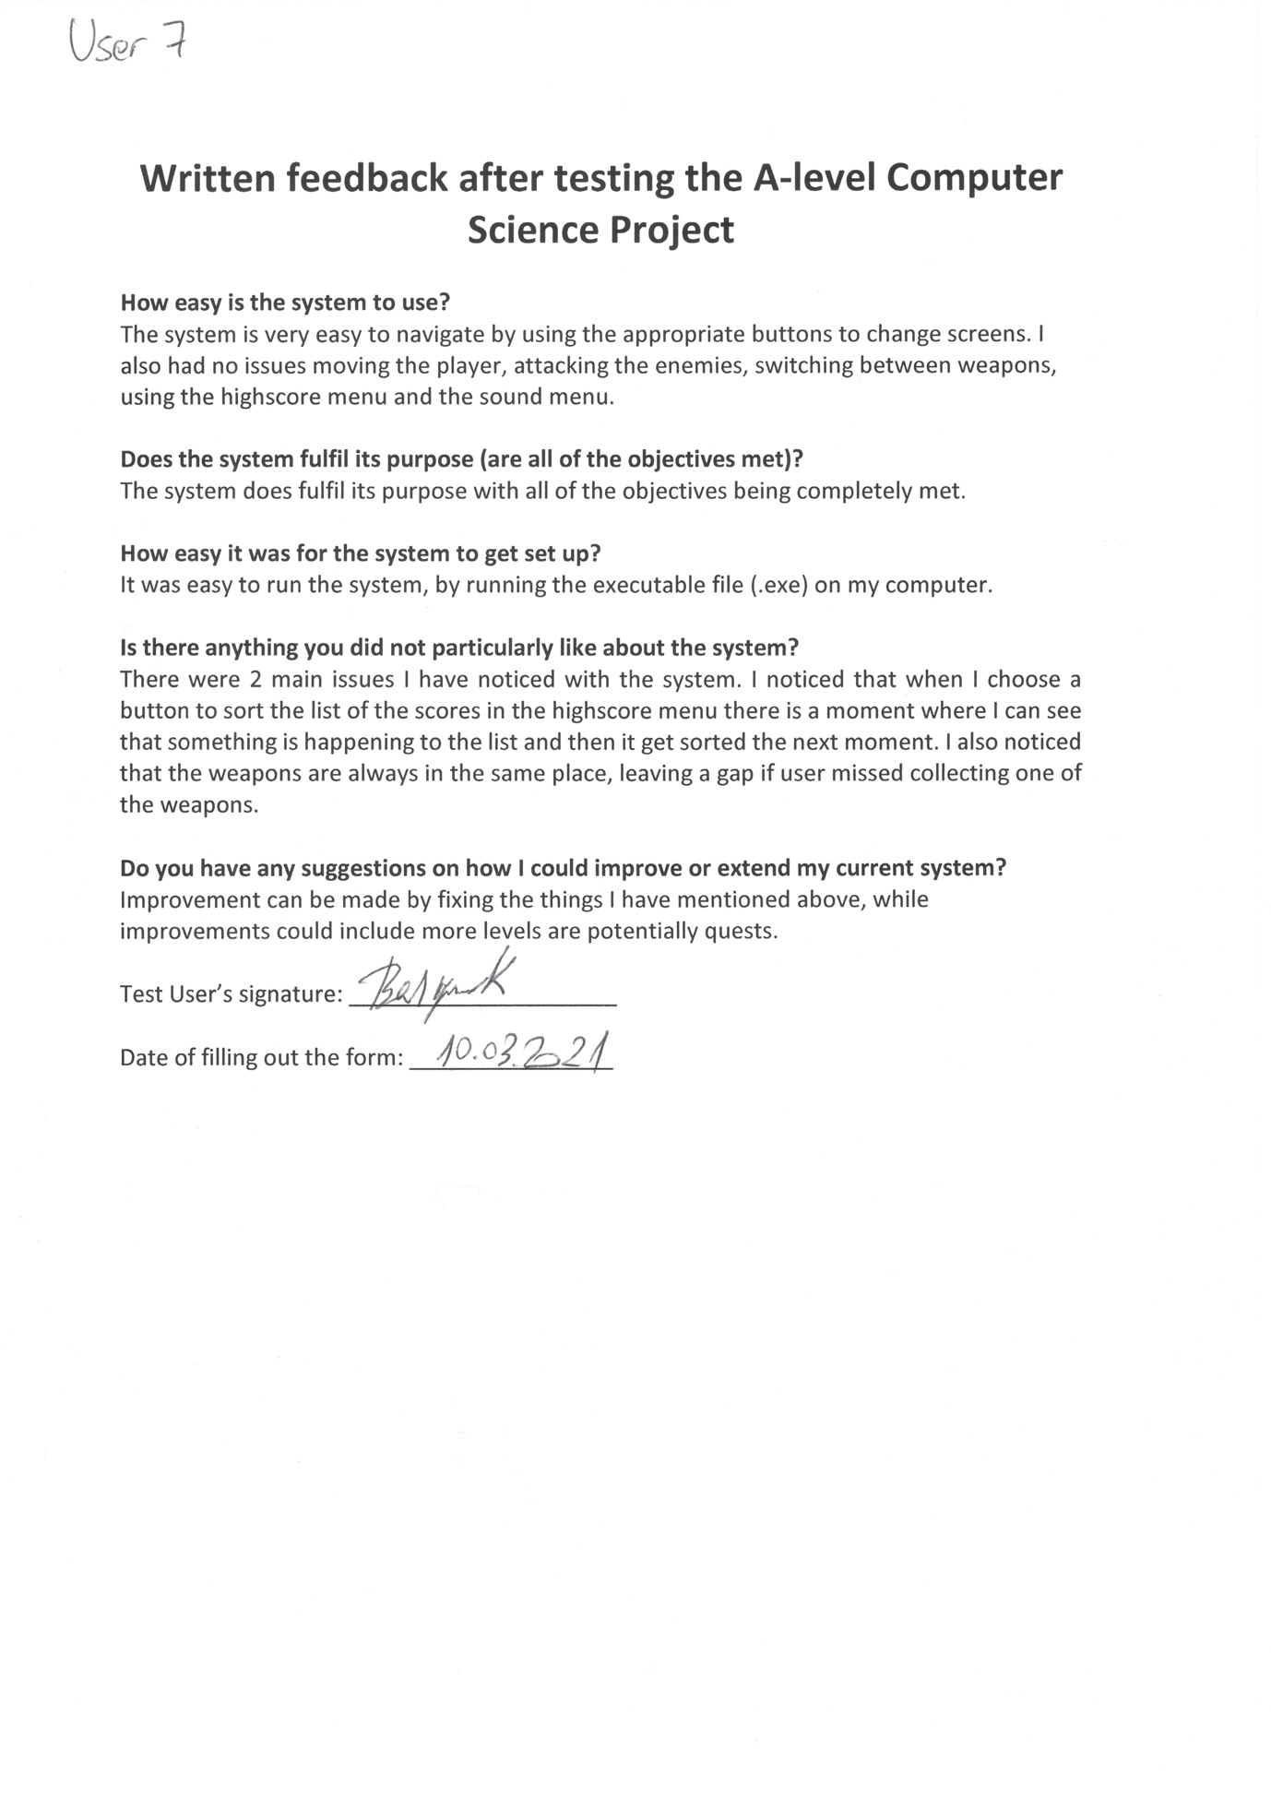

Test User 8:

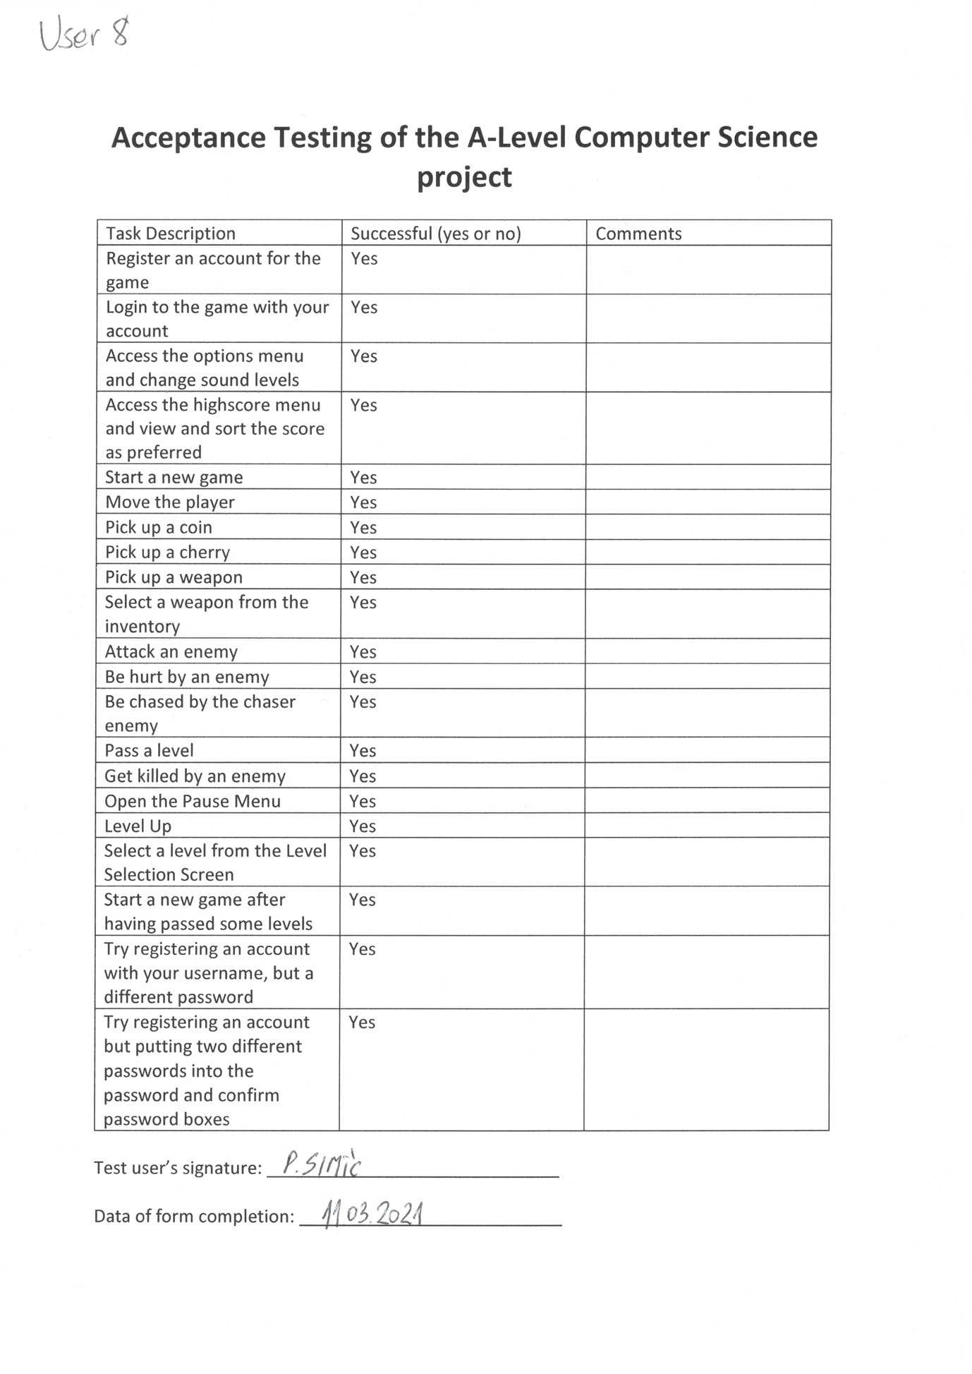

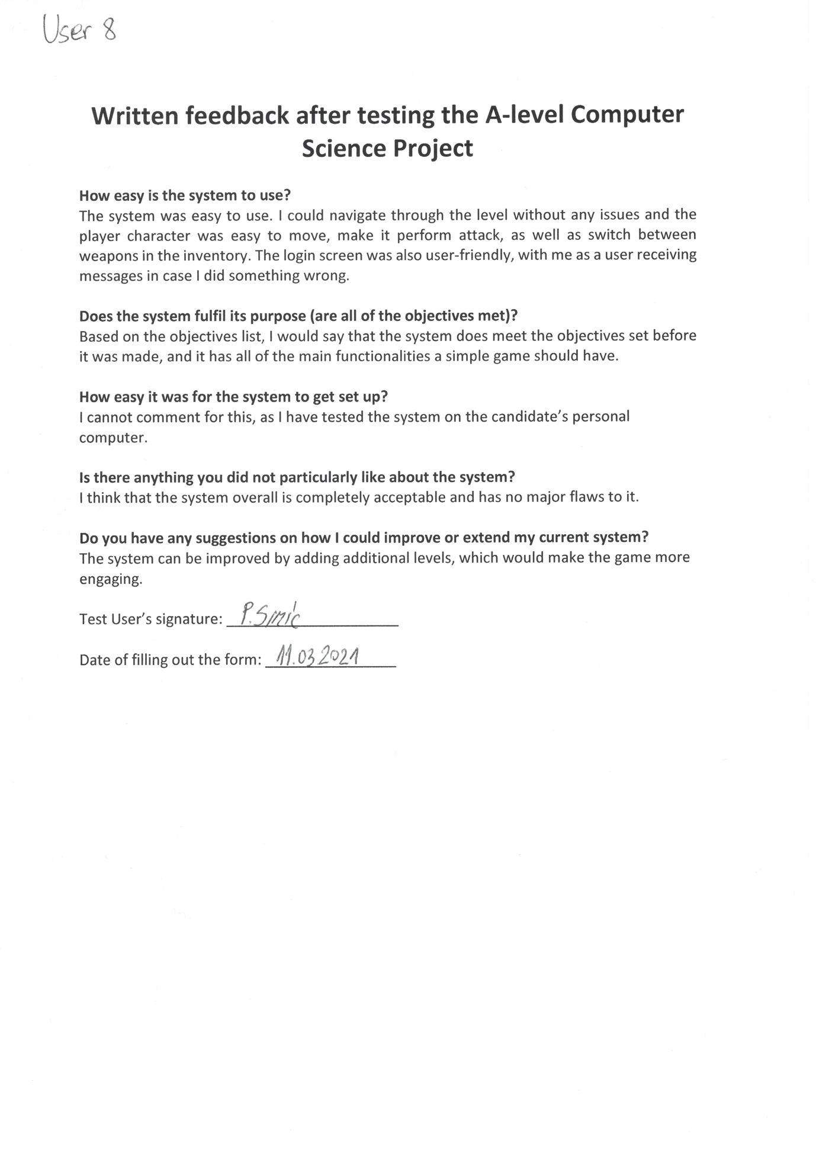

Test User 9:

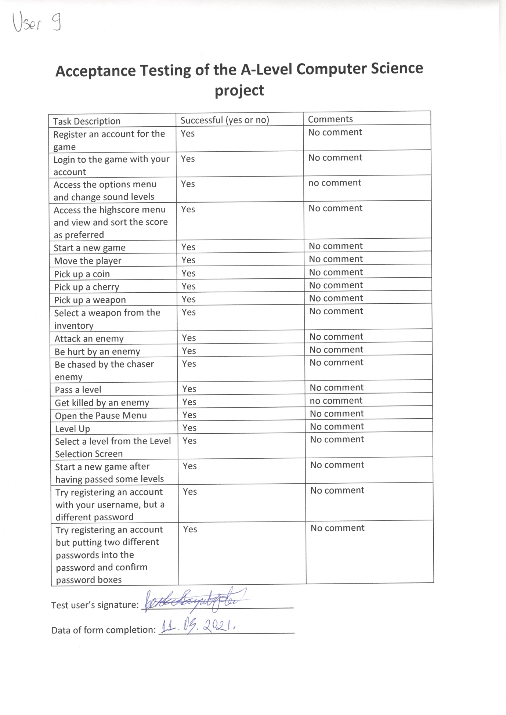

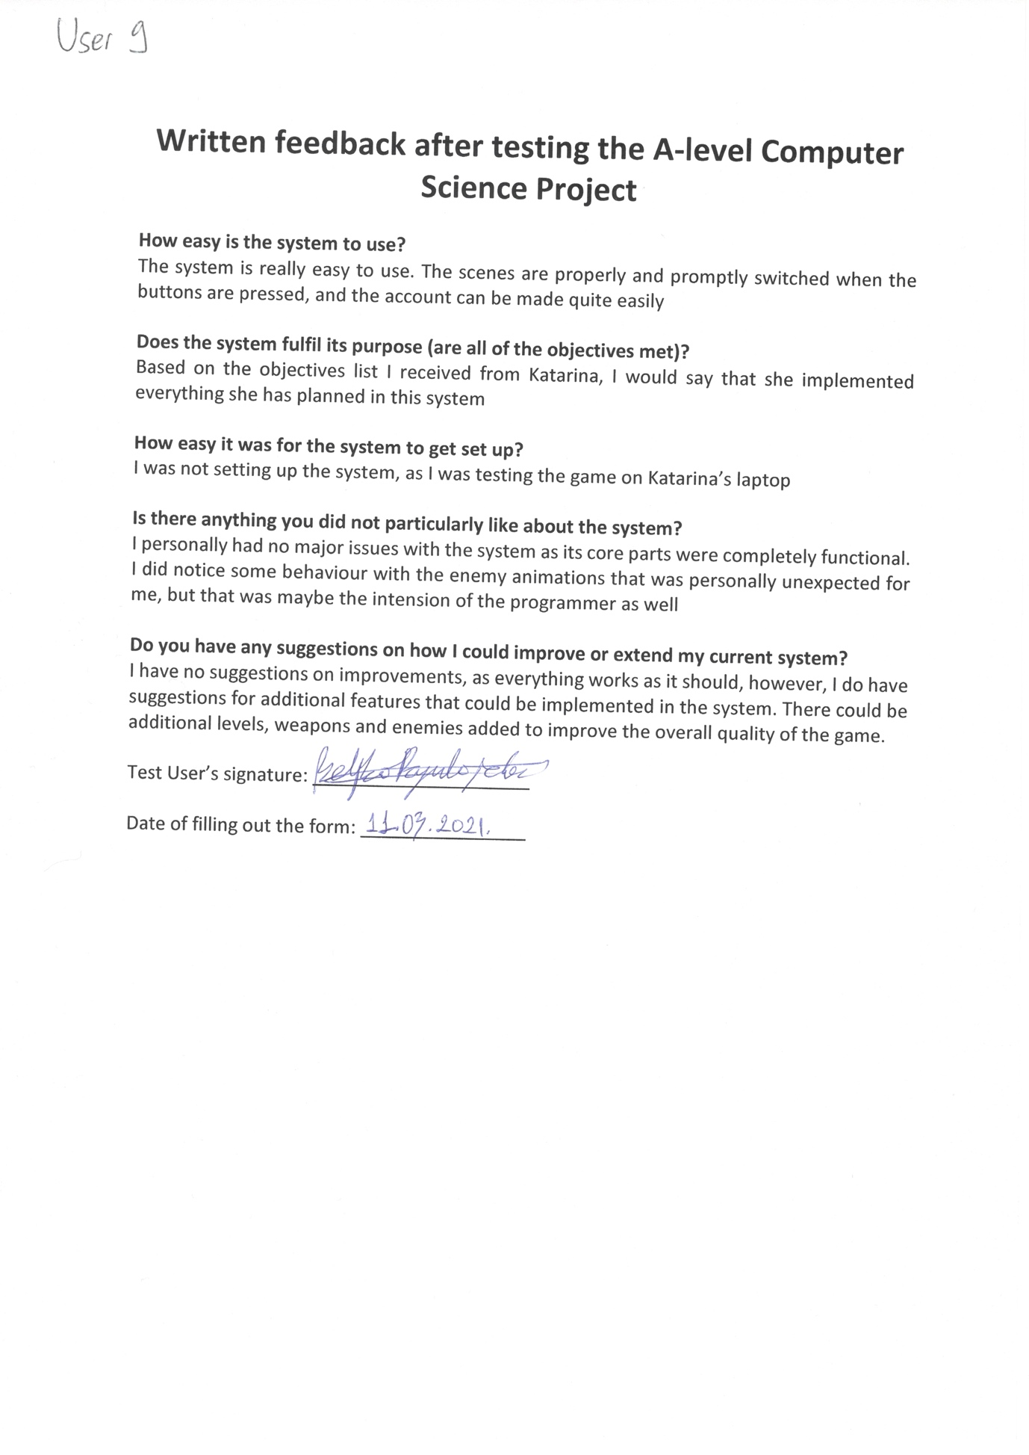

Test User 10: 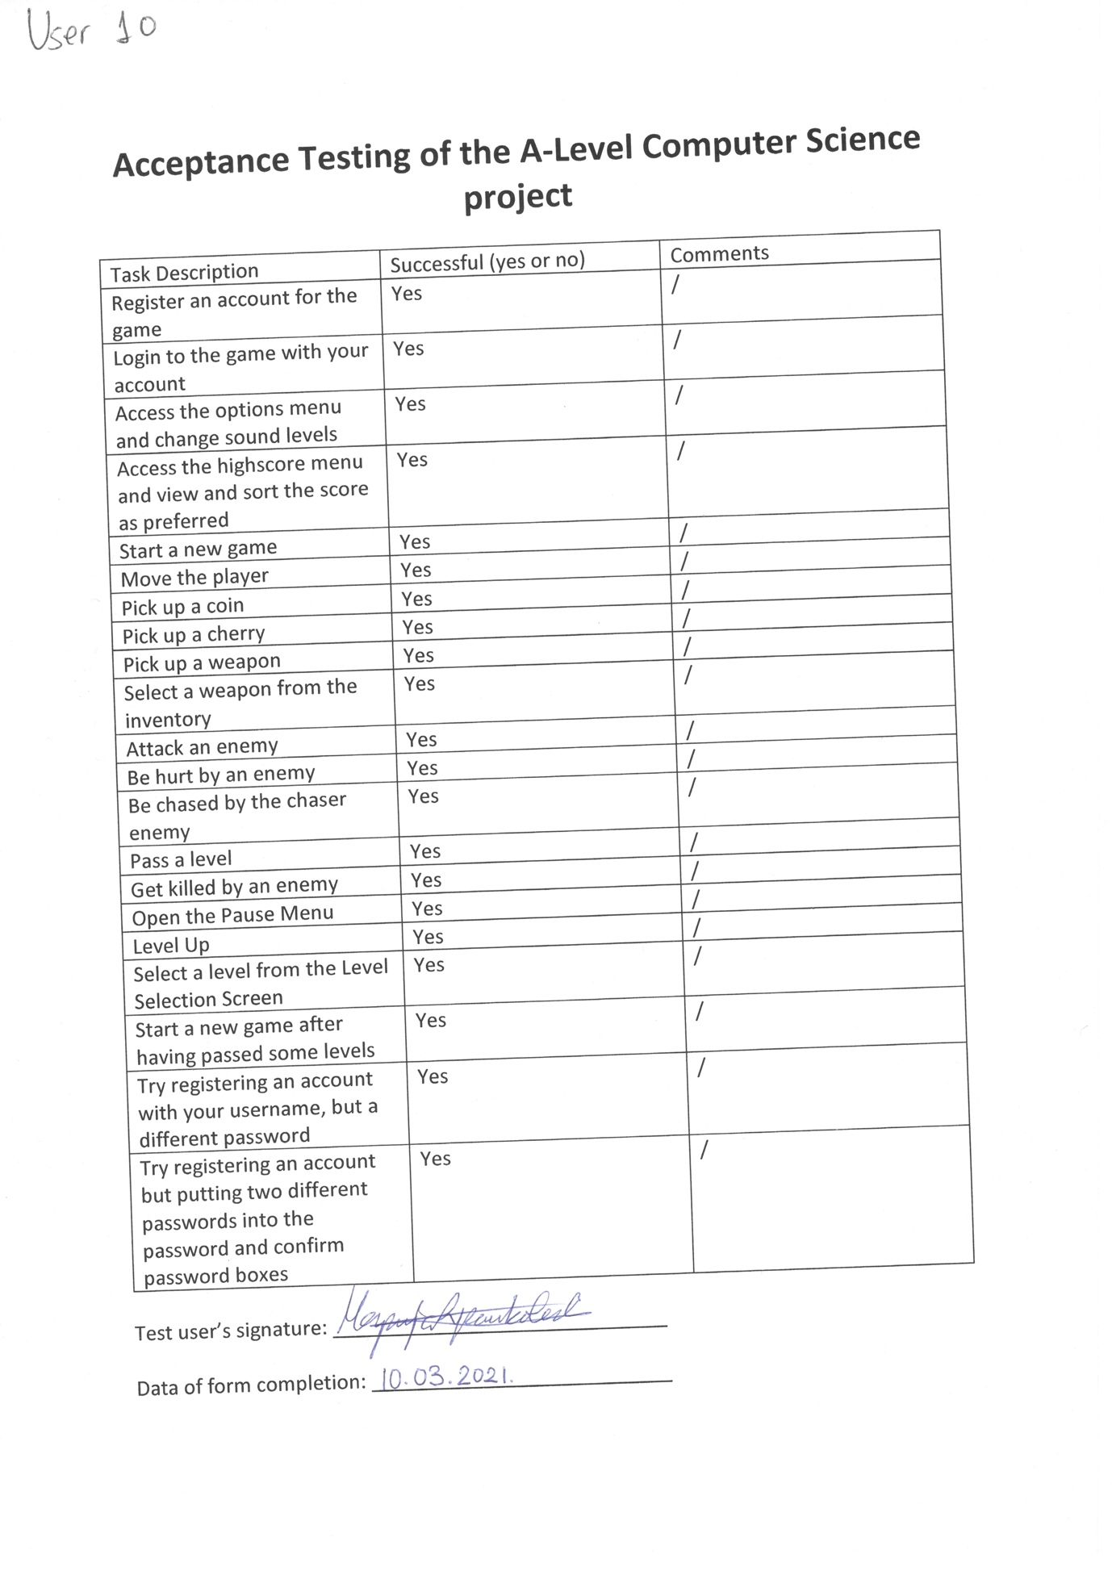

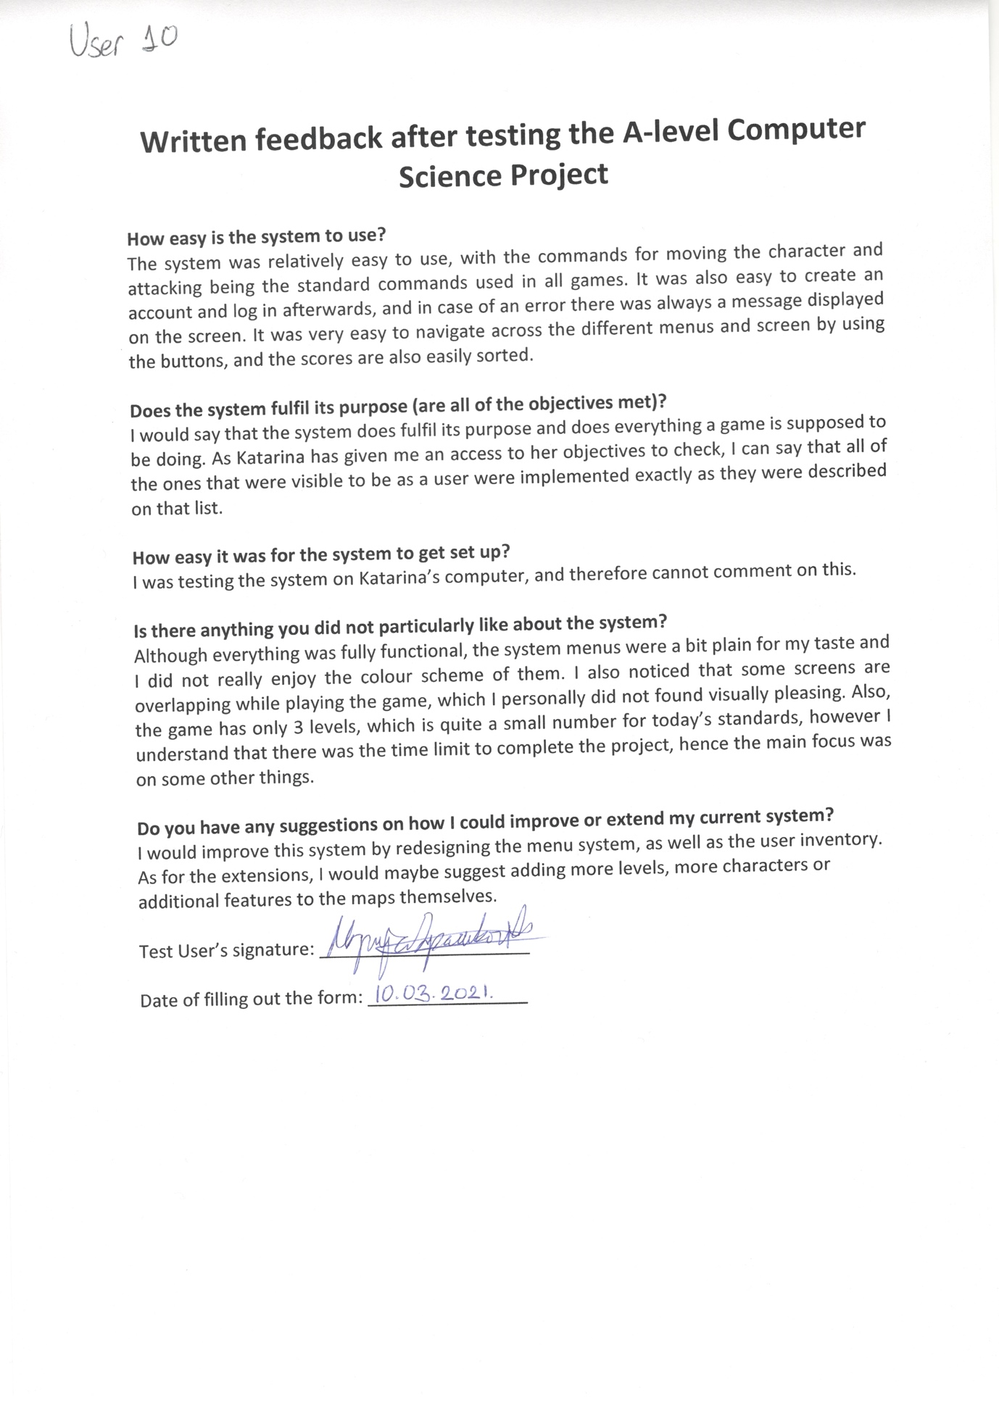

## Analysis of the User Feedback

Overall, the user feedback I received was mostly positive with a couple points about some features that some of the test users did not particularly enjoy, but that did not affect the functionality of the game itself. Looking at the feedback I received, I would say that I managed to achieve what I have planned, using the objectives which I stated in my analysis, with everything working exactly as described.

Functionality-wise, some of the issues I noticed the users were complaining about were the way that inventory works, the scoreboard and the sound managing system. The inventory problem could be potentially fixed by using a stack for the system instead of an array, which will then allow the weapons to be inserted into the inventory as they are collected. The highscore table issue some users pointed out is just the product of the sort being performed, but I will research further to find out how this could be improved for future versions. I understand why some users might get confused with the sound system, as one bar is static while the others are changing. This is technically not a functionality issue; however, one set of bars could be potentially darkened to display which scroll bars are affecting the sound levels at that moment.

Design-wise, there was a complaint about some users regarding the design of the menus. As my primary focus of this project was to showcase my technical skills rather than design skills, the actual design was not as important for the project as the code was, therefore less time was spent on making the game ‘look good’. If this was an actual game that was on the marketplace, all of the game elements would be worked on with the same amount of detail as the design is very important to attract potential new users.

## Potential Improvements and Extensions

Potential Improvements for this game would definitely be fixing the issues highlighted by the users above and in their forms they have returned to me. I would also maybe improve the game by changing the saving game method to the once I had before in the analysis, as it gives the user the flexibility to save their progress mid-level. Another thing I would improve as well would be more rewards for upgrading to the user level, as well as addition levels with their unique features. Finally, the boss level could also be improved, by making the boss enemy intelligent so it can switch between different attack methods and also by creating more options for the user.

As for the extensions, there are various ways how the current system could be expanded. There could be quest introduced to the game which would reward the player once completed. There could also be additional items available to collect, such as different heal items, weapons, and potentially new items altogether. Another way of expanding the system could also be creating more maze and boss level, as well as introducing multi-player support for 2 players to play the game together. There could also be a mode where the user is in the role of the enemy and has to stop the main character from passing the level. This would require implementing an AI script for the main character, so that it could navigate through the maze correctly.

**Exemplar 2:**

***Evaluation***

1. The user should be able to control the movement and function of the player allowing it to move around the game space as well as use the player’s actions. – This objective was completely met: the player can rotate on both mobile versions and desktop versions; the player can move forwards on both the mobile and desktop versions and backwards on the desktop version; there is a health bar that displays the player’s health and mini health bars of other players above their entity; health boosts are randomly generated and can be collected by the player, I have run into an issue with boosts not de spawning instantly and allowing players to reuse them but that is a limitation of Python for the server.

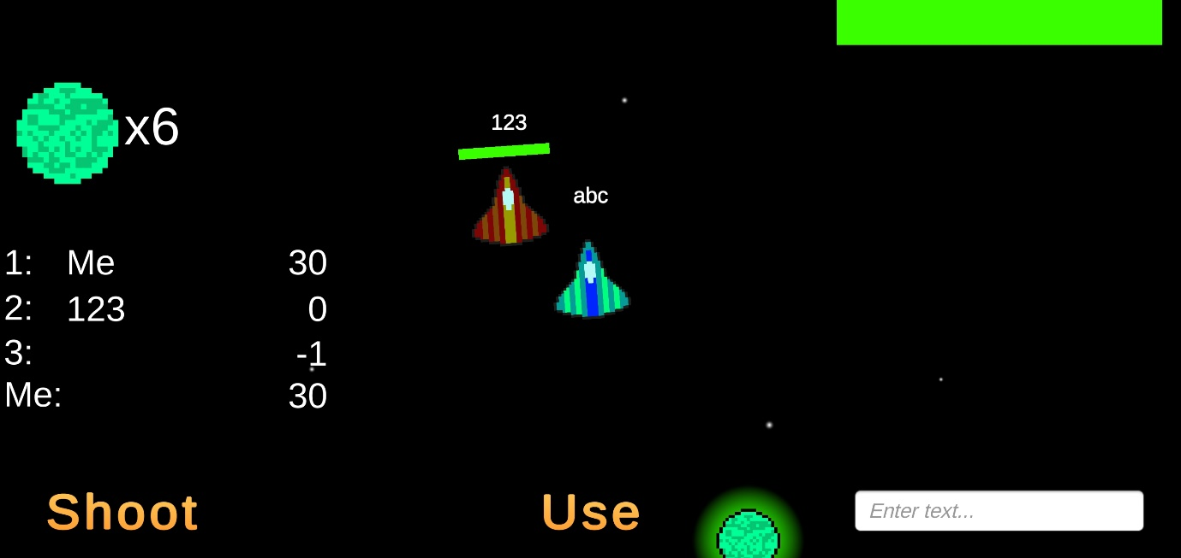 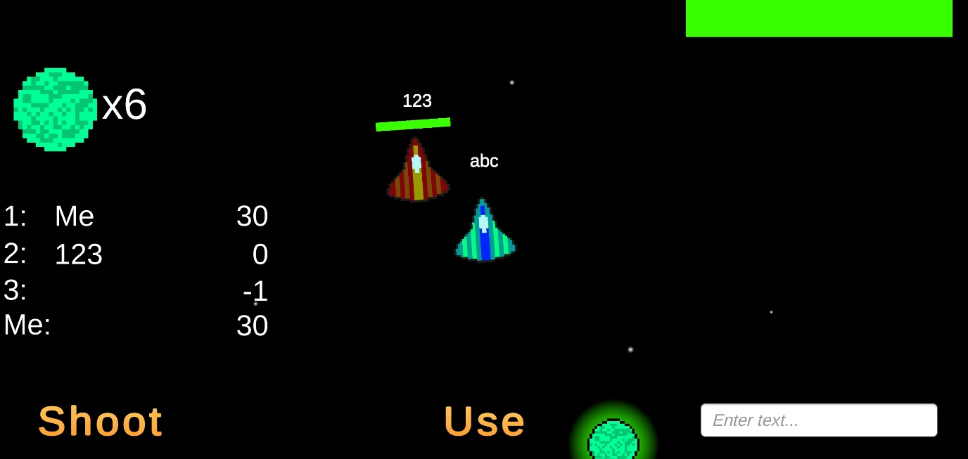

1. The players should be able to communicate. – This objective was partially met: An in-game chat is provided and it a UI element does display the messages of other players. However, mobile users cannot send messages due to there being no Enter key on the mobile keyboard pop-up that Unity allows for. A potential fix for this would be to implement a send button, I did not do this because I felt that the User Interface was already getting very crowded.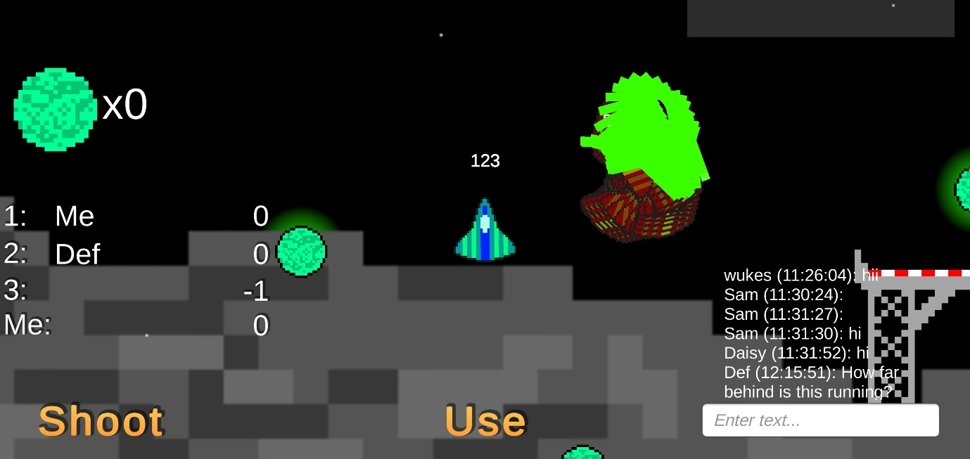
2. There will be a menu that opens on game launch. – This objective was completely met: The user can connect to a server by IP or Domain name in the connect region of the menu; The user can create a User Account in the Sign Up section of the menu as long as their password is longer than 5 characters; Sign Up Passwords require confirmation that is verified in code; Users can login from any device as long as they are connected to the same server as they created the user account on, this could be made to work on any server if I was to connect the game-server to one centralised database server instead of its own local database server however I did not implement this at the moment due to the cost that would be incurred by running a server 24/7.  
   [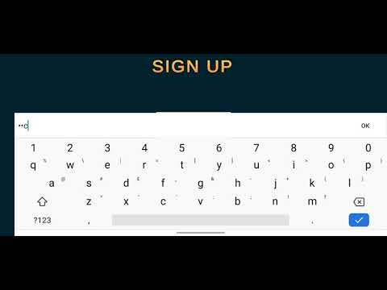](https://www.youtube.com/embed/BJ7RYexYV5U?feature=oembed)
3. Other online players should be displayed to the player. – This objective was partially met: The user can see other players and they do move according to where they are, all their player data is displayed appropriately as well; They do appear in the leader board as well and their score updates according to the score they have accumulated. However, in this project I have used Python to host my server along with a very slow WebSocket package, this has resulted in the speed of the server being significantly less than optimal. If I were to do this project again, I would use a faster Web Socket package as well as data memory caching to store the data temporarily so that database request does not need to be made for every single request. I would also potentially use a faster compiled programming language such as Java, C#, or C++ for the server.
4. The player should be able to collect the object required to win. – This objective was successful. When the user lands on the landing pad their inventory gets updated to have 1 cargo item; 5 points begin to be added to the player’s inventory every 5 seconds; The cargo displayed above online players looks like a treasure chest and is aligned properly with the other UI elements of online players; The cargo is stored as a container within the game allowing it to have an inventory. I could have done this better by making the landing pad a container and giving it the inventory of the cargo.
5. When a player reaches the number of points required to win, the game should pause and display the winner. – This was completely successful. When the user reaches a score above 100 the game freezes and display’s the name of the winner on screen; points are stored as a player state and so can be accessed by all other players, this allows them to be displayed and processed for the leader board.
6. The server should be able to receive HTTP Requests for login, connecting and signup and process them effectively. – This was successful. I have setup a view to handle connection requests, it receives an empty JSON array and then returns an activity state to tell the game that it is online; I have setup a view to handle sign up requests, it receives a username and a password and then checks the database to see if the account already exists. If it does then the server returns this fact and if it does not the server returns that the account does not exist and so the user account has been created; I have also setup a view to handle log in requests. This receives a username and a password and then processes these through the database to see if the user account exists. If it does then the user is returned their information, otherwise they are returned that login was unsuccessful.
7. Web Sockets will be used to transfer data. – This objective was mostly successful. The web sockets accomplish all the goals that I originally set. The game establishes a connection with the server; the game builds a JSON string based on the local player’s data and prepares it to send to the server; the server receives and processes the JSON from the game into the correct database tables; other players can then access this data when they send their own requests to the server; The data for other players is then sent back to the user who sent the request and the data is parsed by the game to display the other players who are online. However, due to the limitations of database connections in python, the speed of the web socket package that I am using and the speed limitations of python itself the requests are not fast enough to stably run a multiplayer game, this results in very high levels of lag when playing and can result in some unpredictable bugs. This could be remedied by using a different programming language that pre-compiles instead of using an interpreted language for my server. I believe that this aspect of python is one of my serious limitations with the server.

**Review of comments from my User Testers (See testing section)**

From my user testers I have been informed that the multiplayer does not run fast enough to be comfortable for a real time game. This is a critical flaw with my game server and game update processing. Instead of sending all the data all the time I should just be sending the things that have changed. Also, I should not be using Python as instead of being a compiled language it uses an interpreter. This causes it to run significantly slower and is not optimized for being a multiplayer server.

The users also said that the login error messages where not particularly easy to understand. I have since rectified this by changing the way that the server communicates login errors. It will now tell you when the password is wrong, or the user has not been found.

The user testers also observed that the respawn function was not working correctly at time of testing. I have fixed this as stated earlier by setting the game time back to 1.

The users have said that the user interface was friendly to use and intuitive for both mobile and desktop use. They did however say that sometimes pressing the menu buttons would take a few clicks. This is an issue with the speed of my server returning a response.

The users have suggested that I design a tutorial for the game to teach new users how it is played as the controls are not necessarily the most intuitive. They cited that using the “a” key for shooting was not the usual controls for that sort of game mechanic.

**Potential improvements for this project could be:**

* Using a CSV format instead of JSON as this would decrease the size of my data transmissions resulting in faster data transmission.
* Using a different programming language for the server, as I have previously stated Python was the wrong choice for a real-time multiplayer game server. It cannot handle the speed at which the requests are made, this server would be more suitable for a turn-by-turn based game where one person does something at any one time. Possible options could be C++, C# or Java.
* I could take further benefit of the fact that I am using Django Channels, to do this I could set up groups of clients so that the clients all talk directly to one another via the server, in a fashion like WebRTC instead of the game clients all talking with the server and then the server sending the player data out as Web Sockets. Instead, the server could simply be used for storing the current state of the game.
* I could make the game menu more self-explanatory. Currently you need to work from the bottom upwards which is not very intuitive, it should be a step-by-step process where one menu takes you to the next.
* I could change the way that game updates are communicated between the game and the server so that only changes are transmitted, this would decrease the processing time per game update resulting in much faster multiplayer speeds.